Name: | ___________________________________________________ |  |  |  | Date: ___________
 | Year 10A Mathematics Course  Test 5 , 2015  Topics – Logs, Exponentials and Finance |  |  |  | 50  = %
Total Time: | 60 minutes
Total Reading: | 5 minutes
Total Working: | 55 minutes
Weighting: | 5 % of the year.
Equipment Allowed: | 1 page notes (A4 both sides), Scientific calculator
SECTION 1: CALCULATOR FREE
Time: | 24 minutes | Marks for Section 1: |  | 22
Reading: | 2 minutes | Equipment Allowed: |  | Nil
Working: | 22 minutes

1. | [6 marks: 1, 1, 1, 1, 1, 1]
 | Complete the logarithm laws below:
a) | $\log{ab}$ = | b) | $\log{\frac{a}{b}}$ =
c) | $\log{a^{n}}$ = | d) | log 1 =
e) | log 10 = | f) | $\log{\frac{1}{a}}$ =

2. | [2 marks: 1, 1]
 | Calculate:
a) | log 100000 = | b) | log $\sqrt[5]{10}$ =
3. | [6 marks: 2, 4]
 | Simplify:
a) | $\log_{2}{12}$ - $\log_{2}{6}$ = | b) | $$\log_{4}{12+3\log_{4}{2- \log_{4}{6 =}}}$$
4. | [8 marks: 2, 4, 1, 1]
a) | Graph the function $y=5^{x}$. Hint: make table of values to calculate x and y coordinates of points on graph.  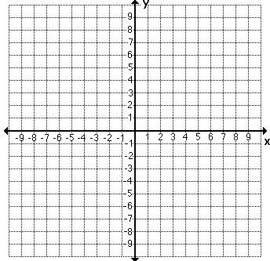
b) | On the same coordinated plane, graph functions $y={-5}^{x}$ and $y=5^{-x}$.
c) | Describe transformations between $y=5^{x}$ and $y={-5}^{x}$.  __________________________________________________________________________________
d) | Describe transformations between $y=5^{x}$ and $y=5^{-x}$.  __________________________________________________________________________________

~END OF SECTION 1~
SECTION 2: CALCULATOR ASSUMED
Time: | 36 minutes | Marks for Section 1: | 28
Reading: | 3 minutes | Equipment Allowed: | Nil
Working: | 33 minutes

5. | [8 marks: 2, 4, 2]
 | Sam wants to borrow $4560 from a bank to by a car. BankWest is charging him 8% interest per annum and he needs to pay it off in 5 years.
a) | Calculate the simple interest he would pay during the time of the loan.
b) | Another bank, Westpac bank, is offering him the same conditions (to borrow $4560 and pay it off in 5 years). The bank says that the total simple interest he would pay is $1596. What is the interest per annum the bank is charging?
c) | Which bank should Sam choose? Explain why.
6. | [6 marks: 3, 3]
 | Calculate how much interest (to the nearest cent) is added over 5 years to the account paying 8% p.a. interest on an initial sum of $34000 if the interest is compounded:
a) | monthly
b) | half yearly
7. | [6 marks: 2, 4]
 | Solve the following equations:
a) | $$2^{4x-5}=8$$ | b) | $$20 ×{0.935}^{x}=52$$
8. | [8 marks: 4, 2, 2]
a) | Graph the function $y=e^{x}$ by first completing a table of values below.  x  y  
b) | Sketch the function and write its equation after $y=e^{x}$ has been translated 4 units up.
c) | Sketch the function and write its equation after $y=e^{x}$ has been reflected about the x-axis.

~END OF SECTION 2~

